Challenger Maker Kit:
Mars Dustbot

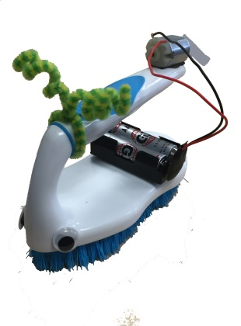
Materials:

Brush
Motor
Hot glue stick portion
9-volt battery clip
Battery holder w/snaps
2 AA batteries
Double-sided foam tape
Googly eyes and chenille sticks

You will need:
Scissors
Masking tape or duct tape (optional)

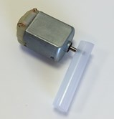
Directions:
fig. 1
- Press the motor’s shaft firmly through the side of the glue stick portion, as shown in figure 1.
- Cut a small piece of foam tape and attach the motor to the end of the brush handle (fig. 2). Make sure the motor’s shaft extends beyond the edge of the brush with the two metal tabs on top. Optional: Wrap tape around the motor and brush handle to make it more secure. O OOptio

- Attach the wires from the 9-volt battery clip to the motor (fig. 2). (Place one wire through each tab and twist each wire to secure them to the tabs without touching each other.)
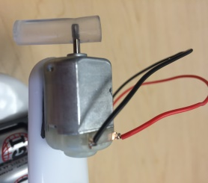
fig. 2
- Load the AA batteries into the battery pack and use the double-sided foam tape to adhere it to the base of the brush (fig. 3).

- Now you are ready to test your simple circuit. Touch the 9-volt battery clip to the clip on the 2-AA battery holder. Your motor should spin without producing any heat. If you experience any heat see Troubleshooting below.

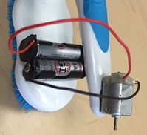
- The battery clip serves as the on/off switch. Attach one contact of the battery clip to the battery pack as shown in figure 4a. This is the off position. For the on position, rotate the battery clip so that both contacts touch (fig. 4b) and watch your Mars Dustbot go!
fig. 3
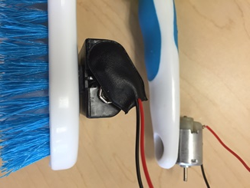
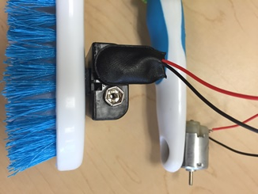
fig. 4b
fig. 4a

Extensions:
Use foam tape, googly eyes, a chenille stick, or anything else you can think of to give your Mars Dustbot some personality!

How can you change your Mars Dustbot’s behavior? Make it faster? Make it slower? Try changing the placement of the glue stick portion on the motor shaft.

Troubleshooting:
My Mars Dustbot is getting hot! You may have wires touching each other creating a short circuit. Make sure each wire only touches one tab on the motor.

My Mars Dustbot won’t move. Make sure all the batteries are properly installed, the glue stick portion is pressed firmly in the motor shaft and at least slightly off-center.

For more fun and information, visit www.ChallengerSTL.org!

