Rocky Planet Picture Show

Introduction:
In this activity, students will use prior knowledge and applied logic to sort facts about the four terrestrial planets (Mercury, Venus, Earth, and Mars) to create a more complete description of each planet. This activity can be used as either a pre-assessment or a post-assessment of students’ knowledge of the four inner planets.
Objectives:
The student will:
- Demonstrate an understanding of planetary characteristics
- Demonstrate an understanding of some of the conditions that support life on Earth
- Discuss, compare, and contrast the differences between four planets in our solar system
- Work with a group of peers to build consensus and express their point of view

Materials: (per group)
- 1 Mercury card, 1 Venus card, 1 Earth card, and 1 Mars card
- 1 Set of planetary facts

Procedure:
- Distribute the materials and instruct the students to place each of the planetary picture cards face up on the table.

- Have the students work in their groups to discuss each fact and come to a group consensus about whether each fact should be placed under Mercury, Venus, Earth, or Mars. (If a group cannot reach a consensus on a fact, that fact must be set aside.)

- Check the facts as a class. Take time to discuss the questions this might raise amongst any of the groups. Also, emphasize the effectiveness of working together as a team to make decisions and reach consensus.

Extensions:
- Instruct the students to use the internet to research the differences between the two planets.
- Have the students create display boards or reports about one or both of the planets.
- Have students use research results to create their own custom planetary fact sets.

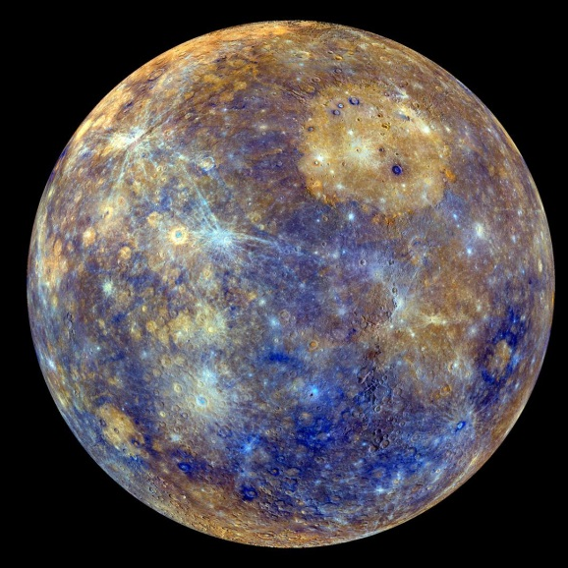

Mercury
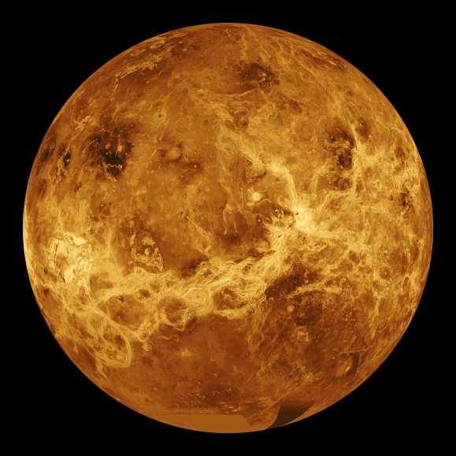

Venus

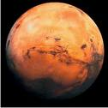
Mars

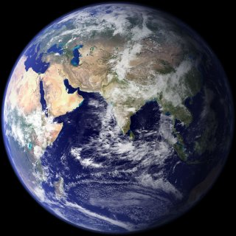
Earth

Mass (10²⁴kg)  0.330 | Mass (1024kg)  4.87 | Mass (10²⁴kg)  5.97 | Mass (10²⁴kg)  0.642
Diameter (km)  4879 | Diameter (km)  12,104 | Diameter (km)  12,756 | Diameter (km)  6792
Gravity (m/s²)  3.7 | Gravity (m/s²)  8.9 | Gravity (m/s²)  9.8 | Gravity (m/s²)  3.7
Length of Day (hours)  4222.6 | Length of Day (hours)  2802.0 | Length of Day (hours)  24.0 | Length of Day (hours)  24.7
Distance from Sun (10⁶ km)  57.9 | Distance from Sun (10⁶ km)  108.2 | Distance from Sun (10⁶ km)  149.6 | Distance from Sun (10⁶ km)  227.9
Orbital Period (days)  88.0 | Orbital Period (days)  224.7 | Orbital Period (days)  365.2 | Orbital Period (days)  687.0
Average Temperature (C)  167 | Average Temperature (C)  464 | Average Temperature (C)  15 | Average Temperature (C)  -65

Mercury | Venus | Earth | Mars
Mass (10²⁴kg)  0.330 | Mass (10²⁴kg)  4.87 | Mass (10²⁴kg)  5.97 | Mass (10²⁴kg)  0.642
Diameter (km)  4879 | Diameter (km)  12,104 | Diameter (km)  12,756 | Diameter (km)  6792
Gravity (m/s²)  3.7 | Gravity (m/s²)  8.9 | Gravity (m/s²)  9.8 | Gravity (m/s²)  3.7
Length of Day (hours)  4222.6 | Length of Day (hours)  2802.0 | Length of Day (hours)  24.0 | Length of Day (hours)  24.7
Distance from Sun (10⁶ km)  57.9 | Distance from Sun (10⁶ km)  108.2 | Distance from Sun (10⁶ km)  149.6 | Distance from Sun (10⁶ km)  227.9
Orbital Period (days)  88.0 | Orbital Period (days)  224.7 | Orbital Period (days)  365.2 | Orbital Period (days)  687.0
Average Temperature (C)  167 | Average Temperature (C)  464 | Average Temperature (C)  15 | Average Temperature (C)  -65

