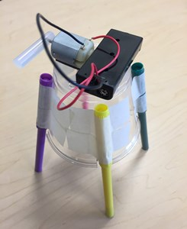
Challenger Maker Kit:
MarkerBot

Included materials
1 plastic cup
4 markers
Foam tape
Motor
Hot glue stick portion
1 battery case with wires
2 AAA batteries

You will need
Scissors
Masking tape

Attach the markers
- Use either the 3 or 4-marker template to mark where the notches will be made on the top of the cup (depending on your preference).
- Cut notches in the cup that extend just beyond the cup’s rim and bend towards the inside of the cup
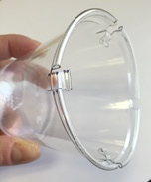

- Hold each marker up-side down such that the marker cap is along the cup and the edge of the cap aligns with the edge of the marker notch. Use two pieces of tape to secure each marker cap to the cup. Flip cup upside-down.

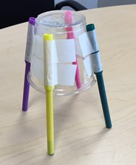

(over)

Assemble the motor and battery kit
- Poke the axle of the motor through the side of the glue stick, off-center. The more off-center the glue stick is, the more the robot will jiggle.
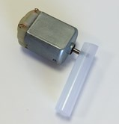

- Use the foam tape to adhere the motor to the cup, ensuring that the metal contacts are on top and the axle and glue stick hang off the edge without the glue stick ever touching the cup or markers.
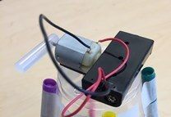

- Install the batteries into the battery pack and use the foam tape to tape it to the top of the MarkerBot. Make sure the battery pack is turned off.

- Bend both wires extending from the battery pack so that they make hooks. Hook one wire into one hole in the motor contact, and the other wire into the other hole. Pinch & twist to keep them in place.

Use the MarkerBot
- Create a safe space for the marker-bot to jiggle around on. Consider an area covered with newspaper, or put a piece of paper on a tray.
- Keeping the marker caps secured onto the cup, take the markers out and reinsert to expose the marker tip. Set the MarkerBot on the paper, turn it on, and watch it create art!
For more fun and information, visit www.ChallengerSTL.org!

