Challenger Maker Kit:
Stomp Rocket

Materials included:

Bottle adapter
PVC pipe
Plastic tubing
Fin & nosecone template
Construction paper

You will need:
Masking tape
Scissors
Empty 2 liter bottle with cap removed

Rocket Assembly:
- Wrap the construction paper lengthwise around the PVC pipe and tape.

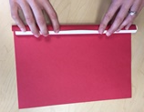

- Remove the PVC pipe and tape one end of the rocket closed with masking tape.

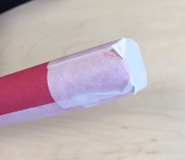

- Cut out the nose cone and twist one end under the other. Continue twisting the nose cone until it is small enough to fit on top of the rocket and tape. Tape the nose cone onto the end of the rocket that you sealed off (keeping the bottom end of the rocket open).
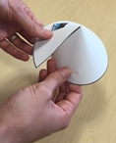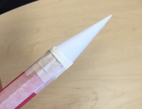

- Choose a fin design and cut out either 3 or 4 fins (based on your design preference). Cut on the solid lines, including the two small slits, which will create three tabs. Fold the center tab one direction and the outer two tabs the opposite direction. Tape each fin onto the bottom of the rocket, making sure they are evenly spaced and facing the same direction. (Clear tape or masking tape can be used for this.)

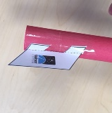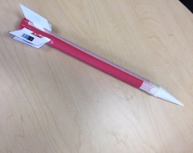

Assemble the rocket launcher
- Screw on the connector to the top of an empty 2 liter bottle.
- Attach the tubing and PVC pipe to the connector.
- Wrap a piece of tape to secure connection between the rubber tubing and PVC pipe
- Have a friend hold the tube (or secure onto something with tape), make sure nobody is in your path, and stomp!

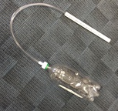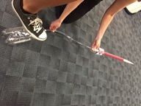

For more fun and information, visit www.ChallengerSTL.org!

